Web Application Security
Web application security means protecting a web application, its users, APIs, servers, and data from unauthorized access, modification, theft, or disruption.
A simple way to think about it:
Browser
↓
Frontend
↓
API / Backend
↓
Database
↓
External services
Security has to exist at every layer.
CIA Triad
A fundamental security concept is the CIA Triad.
CIA means:
C → Confidentiality
I → Integrity
A → Availability

Confidentiality
Only authorized users should see information.

Example:
User A → Can see User A's salary
User B → Should NOT see User A's salary
If User B can access it:
Confidentiality violation

Integrity
Data should not be modified by unauthorized users.

Example:
Original:

salary = ₹50,000
Attacker changes:
salary = ₹5,00,000
That's an integrity violation.

Availability
The application should remain available.

Example:
Normal:

100 requests/sec
Attacker sends:
1,000,000 requests/sec
Server becomes unavailable.

This is commonly associated with:
DDoS — Distributed Denial of Service

Authentication vs Authorization

Authentication
Authentication answers:
Who are you?

Example:
Username: anand
Password: ********
↓
Server verifies credentials
↓
Authenticated

Authorization
Authorization answers:
What are you allowed to do?

Example:
Anand
Role = Employee

Employee can:
View profile
View attendance
But cannot:
Delete employee
Create salary record
Access admin settings

So:
Authentication = Who are you?

Authorization = What can you do?

Cross-Site Scripting — XSS
XSS means an attacker manages to execute malicious JavaScript in another user's browser.

Suppose you display:
element.innerHTML = userInput;
User enters:
<script>alert('Hacked')</script>

The browser may interpret it as HTML/JavaScript.

Example of Dangerous innerHTML
Bad:
const name = userInput;

document.getElementById("message").innerHTML =
"Hello " + name;

If:
userInput =
<script>...</script>
you're potentially executing attacker-controlled code.

Safer textContent
Use:
document.getElementById("message").textContent =
userInput;

Now:
<script>alert('Hacked')</script>

is displayed as text instead of being executed.

DOM-Based XSS
The vulnerability exists primarily in client-side JavaScript.

Cross-Site Request Forgery — CSRF
It is a web security attack where an attacker tricks a user’s browser into sending an unwanted request to a website where the user is already authenticated.

The server may process that request because the browser automatically sends the user's authentication cookies.

CSRF is different from XSS.

Example
Imagine you're logged into:
bank.com
Your browser has:
bank_session=abc123
An attacker creates another website:
evil.com
and tricks you into submitting a request to:
bank.com/transfer
Your browser might automatically include the bank cookie.

The server may think:
Request came with valid session
↓
Execute transfer

That's the basic CSRF problem.

Simple real-world example
Imagine you are logged in to your bank website.

You have a session cookie:
Cookie: session_id=abc123

Now you visit an attacker's website.
The attacker tricks your browser into sending a request to the bank:

POST /transfer-money
The request transfers ₹10,000 to the attacker's account.

Your browser automatically sends the bank's session cookie, so the bank may think:
"This request is coming from the logged-in user."
The attacker does not necessarily know your password or session cookie. The browser sends the authentication automatically.

That is the core idea of CSRF.

How CSRF works

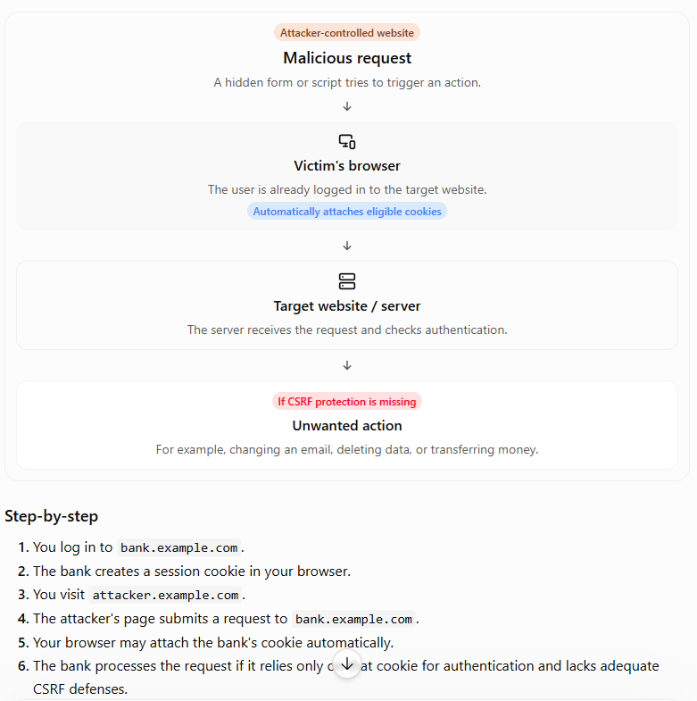

CSRF vs XSS
These two vulnerabilities are commonly confused.
CSRF | XSS
Cross-Site Request Forgery | Cross-Site Scripting
Tricks the browser into sending an unwanted request. | Injects or executes malicious JavaScript in a trusted page context.
Usually abuses existing authentication. | Exploits unsafe handling of untrusted content.
Example: Transfer money using a victim's session. | Example: Inject a script that runs on a banking page.
Main defense: CSRF tokens, SameSite cookies, origin checks. | Main defense: Output encoding, safe DOM APIs, CSP.

Simple difference
CSRF:
"Make the victim's browser perform an action."
XSS:
"Make the victim's browser execute malicious code."

Can XSS bypass CSRF protection?
Yes, often.
If an attacker has script execution in your application's trusted origin, the attacker may be able to read CSRF tokens from the DOM or make requests that include them.

Therefore:
CSRF tokens do not replace XSS protection.

CORS
CORS means:
Cross-Origin Resource Sharing

Suppose frontend runs at:
https://frontend.com

Backend:
https://api.example.com

These are different origins.
Browser security policies may restrict frontend JavaScript from reading responses from another origin unless the server permits it.

Server may return:
Access-Control-Allow-Origin: https://frontend.com

Important CORS Misunderstanding
CORS is not authentication. It will not block hackers.
CORS mainly controls whether a browser allows frontend JavaScript from another origin to access responses.
A malicious server-side script can often call your API without being subject to browser CORS restrictions.

Bad CORS Configuration
Potentially dangerous:
Access-Control-Allow-Origin: * // not recommended

Especially if you're dealing with sensitive APIs and credentialed browser requests.
You should explicitly define trusted origins where appropriate.

Example:
Access-Control-Allow-Origin:
https://myfrontend.com

Content Security Policy — CSP
It tells the browser which sources of content are allowed to execute/load?

Example:
Content-Security-Policy:
default-src 'self';
script-src 'self';
style-src 'self' 'unsafe-inline';
img-src 'self' https:;

CSP Example
Suppose your website contains:
<script src="https://evil.com/hack.js"></script>

If CSP says:
script-src 'self'
the browser can block that script because it isn't from your own origin

CSP and CDN
Suppose your application needs:
https://cdn.jsdelivr.net

You may allow it:
script-src 'self' https://cdn.jsdelivr.net;

For styles:
style-src 'self' https://cdn.jsdelivr.net;

For fonts:
font-src 'self' https://fonts.gstatic.com;

For API:
connect-src 'self' https://api.example.com;

Different directives control different resource types.

Important CSP Directives
Common directives:

default-src
script-src
style-src
img-src
font-src
connect-src
media-src
frame-src
object-src
worker-src
base-uri
form-action
frame-ancestors

Example:
Content-Security-Policy:
default-src 'self';
script-src 'self' https://cdn.example.com;
style-src 'self' 'unsafe-inline';
img-src 'self' data: https:;
connect-src 'self' https://api.example.com;
object-src 'none';
frame-ancestors 'none';
unsafe-inline
You may see:
style-src 'self' 'unsafe-inline'

This permits inline styles.
But:
script-src 'self' 'unsafe-inline'

is much more concerning because it allows inline JavaScript, weakening CSP's protection against XSS.

HTTPS
HTTP:
http://example.com

HTTPS:
https://example.com

HTTPS provides encrypted communication using TLS.

Without HTTPS, network attackers may potentially observe or manipulate traffic.

HTTPS protects things such as:
Login credentials
Cookies
API requests
Personal data
Payment information

HSTS
HSTS:
HTTP Strict Transport Security
Example:
Strict-Transport-Security:
max-age=31536000; includeSubDomains
It tells compatible browsers:
Use HTTPS for this site rather than HTTP.
What is a Refresh Token?
A refresh token is a long-lived token used to get a new access token when the current access token expires.

The easiest way to understand it is:
Access Token = temporary permission to access APIs
Refresh Token = permission to get a new access token

Access Token expires
↓
Frontend sends Refresh Token
↓
Server validates Refresh Token
↓
Server generates NEW Access Token
↓
User continues using application

What is TLS?
TLS = Transport Layer Security
TLS is a security protocol that protects data while it travels between a client (browser/frontend) and a server/backend.
In simple words:
TLS encrypts the communication between your browser and the server so attackers cannot easily read or modify the data while it is travelling over the network.

What does TLS provide?
TLS primarily provides three important security properties.
1. Confidentiality
Data is encrypted.
2. Integrity
TLS helps detect if the communication has been modified in transit.
3. Authentication
TLS certificates help the browser verify that it is communicating with the intended server/domain.

What is Same-Origin Policy?
Same-Origin Policy (SOP) is a browser security mechanism that controls how JavaScript from one origin can interact with resources from another origin.
It is one of the most important browser security concepts.
The basic idea is:
A webpage should not be allowed to freely access sensitive data belonging to another website.
Imagine you're logged into:
https://bank.com
and then you visit:
https://evil.com
Without browser security restrictions, JavaScript on evil.com could potentially try to access information from bank.com.
That would be extremely dangerous.
So browsers enforce the Same-Origin Policy.

What is an Origin?
An origin consists of three things:
Protocol + Host + Port
For example:
https://example.com:443

has:
Protocol = https
Host = example.com
Port = 443
Two URLs have the same origin only when all three match.

Same-Origin Policy is a browser security mechanism that restricts JavaScript running on one origin from freely accessing resources or data from another origin. An origin is defined by protocol, host, and port. CORS provides a controlled mechanism for servers to allow specific cross-origin access.

